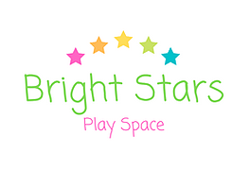

**Toddler Yoga Safety guidelines**

Please read these guidelines carefully before you attend your first class.

What to bring with you:

* Your Toddler!

Only caregivers work with their own toddler.

When practicing with your toddler, never rush or force anything. If you feel stressed or tense, just take a break and come back to the practice later. Always ensure that you feel safe, secure and confident with the way you are holding or working with your toddler. Never do anything that you do not feel comfortable with.

If your Toddler is unwell, it is best not to attend the Yoga class. If your Toddler is crying excessively and cannot be comforted, he/she may be ill. Never practice on a distressed Toddler, or if your Toddler is limp, pale, has a temperature or any difficulties breathing. Please seek appropriate medical help.

It is not recommended to practice within 24 hours of your Toddler’s immunisations.

Thanks M & C.

**Disclaimer**

Please sign the following disclaimer.

* I have read the above safety guidelines and will ensure that I adhere to them.
* I take full responsibility for myself and my Toddler and for everything that happens to me and my Toddler in relation to the Toddler Yoga class.
* If I have any doubts, I will seek the advice of my medical professional before proceeding with Toddler Yoga classes.
* I will keep the Toddler Yoga Teacher informed of any health issues that arise over the course of the classes, both for me and my Toddler.
* I understand that refunds are not possible for missed classes.

Signed: …………………………………………….………….….

Date:……………………………

Thank you for completing this form. The information you give is treated as confidential.